22) Write a C program to perform Selection sort

#include<stdio.h>

int main()

{

int num[10],i,j,temp,min;

printf("Enter 10 numbers\n");

for(i=0;i<10;i++)

{

scanf("%d",&num[i]);

}

printf("\nEntered numbers:");

for(i=0;i<10;i++)

{

printf("%d.",num[i]);

}

printf("\n\n");

for(i=0;i<9;i++)

{

min=i;

for(j=i+1;j<10;j++)

{

if(num[j]<num[min])

{

min=j;

}

}

temp=num[i];

num[i]=num[min];

num[min]=temp;

}

printf("Sorted array:");

for(i=0;i<10;i++)

{

printf("%d.",num[i]);

}

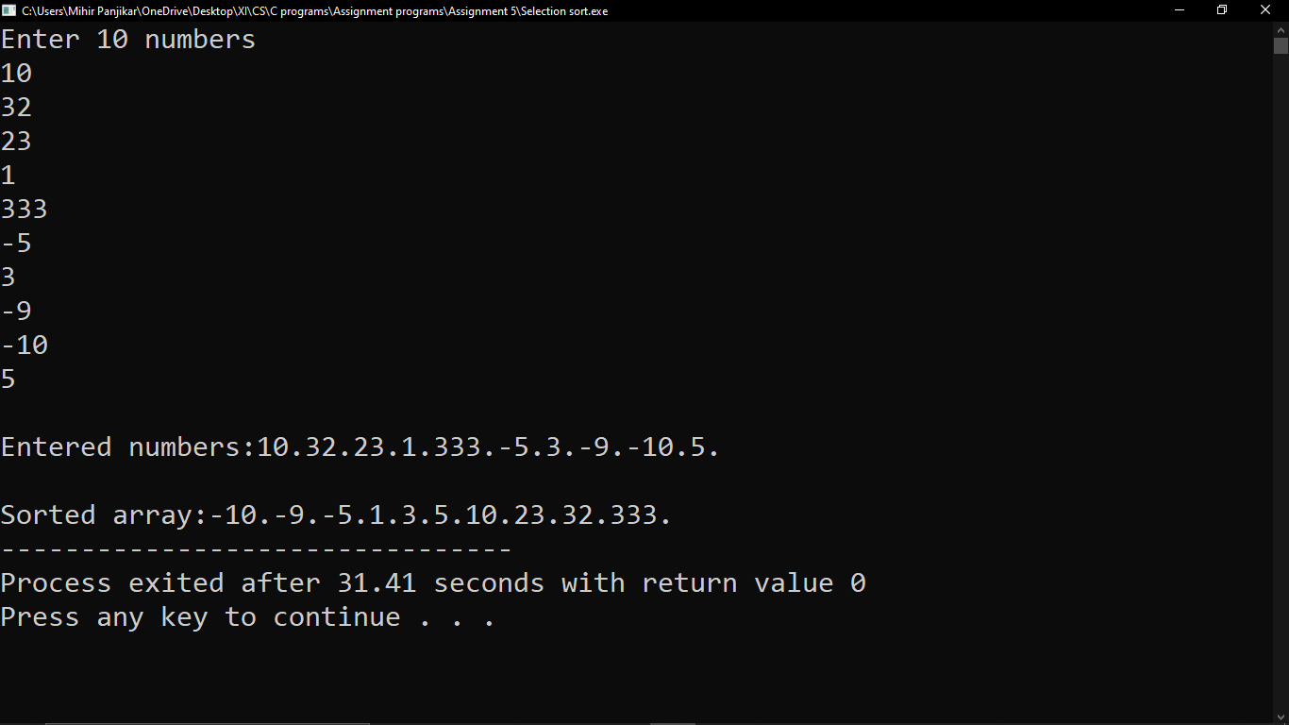}

23) Write a C program to perform binary search

#include<stdio.h>

int main()

{

int low,high,mid,key,temp,i,j,n,found=0,min;

printf("Enter how many numbers you want to insert in the array\n");

scanf("%d",&n);

int arr[n];

low=0;

high=n-1;

mid=(high+low)/2;

printf("Enter the numbers\n");

for(i=0;i<n;i++)

{

scanf("%d",&arr[i]);

}

printf("\nEntered array:");

for(i=0;i<n;i++)

{

printf("%d.",arr[i]);

}

for(i=0;i<n-1;i++)

{

min=i;

for(j=i+1;j<n;j++)

{

if(arr[j]<arr[min])

{

min=j;

}

}

temp=arr[i];

arr[i]=arr[min];

arr[min]=temp;

}

printf("\n\nsorted array:");

for(i=0;i<n;i++)

{

printf("%d.",arr[i]);

}

printf("\n\nEnter element you want to find:");

scanf("%d",&key);

while(low<=high)

{

mid=(low+high)/2;

if(key<arr[mid])

{

high=mid-1;

}

else if(key>arr[mid])

{

low=mid+1;

}

else if(key==arr[mid])

{

printf("\nFound at location %d\n",mid+1);

found=1;

break;

}

}

if(found!=1)

printf("\nElement not found");

printf("\n\n");

}

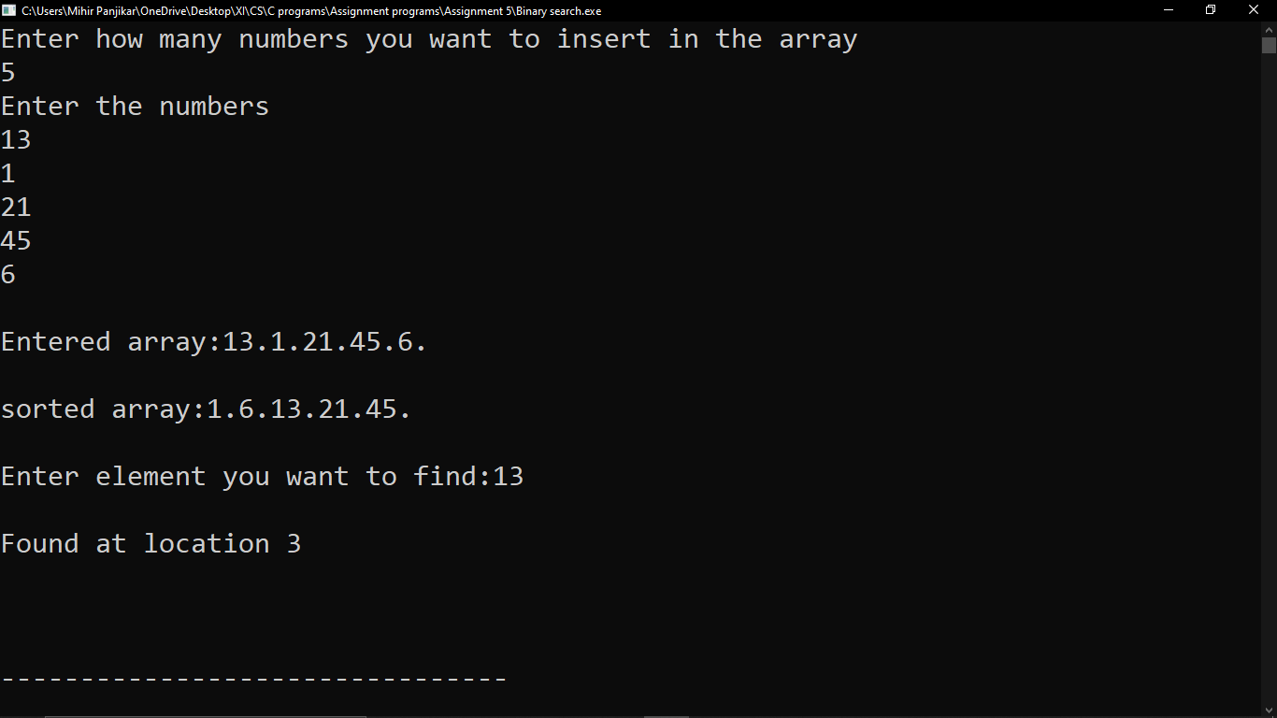

24) Write a C program to find the sum of each row and column in a matrix.

#include<stdio.h>

int main()

{

int a[10][10],sum_row,sum_col,r1,c1,i,j,k;

printf("enter the number of rows and columns of the matrix\n");

scanf("%d%d",&r1, &c1);

printf("enter the matrix elements\n");

for(i=0;i<r1;i++)

{

for(j=0;j<c1;j++)

{

scanf("%d",&a[i][j]);

}

}

k=1;

for(i=0;i<r1;i++)

{

sum_row=0;

for(j=0;j<c1;j++)

{

sum_row+=a[i][j];

}

printf("sum of row %d = %d\n",k++,sum_row);

}

k=1;

for(i=0;i<c1;i++)

{

sum_col=0;

for(j=0;j<r1;j++)

{

sum_col+=a[j][i];

}

printf("sum of column %d = %d\n",k++,sum_col);

}

}

